HTML 2 Exercises

In the following exercise, build on the previous website that you have already built. And again don’t forget to commit and push your code after each exercise.

# Exercise 1: Advanced Table (Special Exercise)

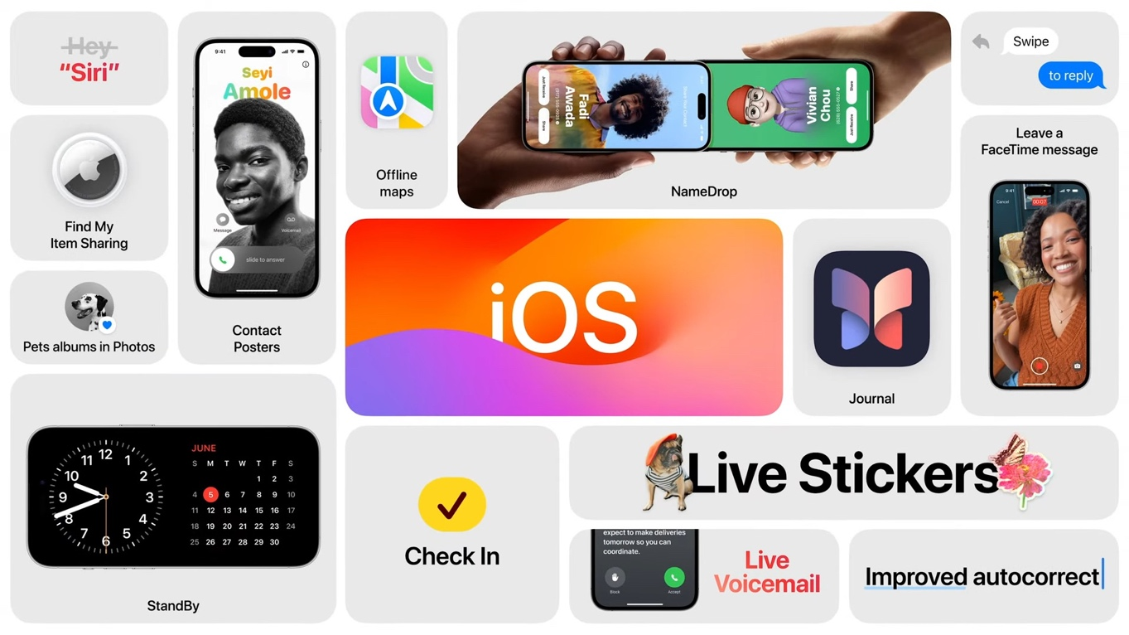

Let’s assume you go the opportunity to feature your website in an event or so, and you wanted to create a figure on your website that promotes a list of benefits of using your website.

Go back to your website and **use <table>** to create a list of features as it is shown in the figure above.

For now you can use the same assets as the figure above (*found in Web-Dev-Course/Lectures/03 HTML /Exercise Files/assets*)

Think creatively!

# Exercise 2: Complex form

You want to allow people to engage with you through your website. This can be in terms of hiring you, suggesting some resources to, write a comment to your articles, etc. (It depends on your website idea). However you do not want anyone to apply, so you a have a set of screening questions to filter out some applications. In this exercise do the following:

* Think of a type of engagement you want to include in your website
* Create a new subpage with the title of the form (hire me, order now, submit a proposal, etc.)
* Include at least 5 screening questions covering 5 or more different form elements
* Use autocomplete, placeholders and data-lists within your form
* When someone submits the form, take them to a thank you subpage and include the link of the main page in the confirmation page to allow people to go back to the main page.

# Exercise 3: Semantic Structure

You have now a good webpage, but this page structure needs to be semantically meaningful to increase its readability and allow apps like web crawlers and screen readers to make sense of it. Go back to all of your web pages and refactor them to semantic structure elements (i.e. nav, figure, article, section, header, aside INSTEAD OF <div> elements).

# Exercise 4: Footer

Every page needs better have a footer that allow users to quickly find links, contact information and copyright info of the website. Add a footer to your HTML main page that has all the links of the other pages, your contact info and a statement about the copyrights.